1) Таблица истинности

|  |  |  |  |  |  |  |  |  |  |
| --- | --- | --- | --- | --- | --- | --- | --- | --- | --- |
| *N* | $$x_{1}x_{2}x_{3}x_{4}x_{5}$$ | $$x_{1}x_{2}x_{3}$$ | $${(x_{1}x_{2}x_{3})}_{10}$$ | $$x_{4}x_{5}$$ | $${(x_{4}x_{5})}_{10}$$ | $$(+)$$ | $$x_{3}x_{4}x_{5}$$ | $${(x_{3}x_{4}x_{5})}_{10}$$ | *f* |
| 0 | 00000 | 000 | 0 | 00 | 0 | 0 | 000 | 0 | 0 |
| 1 | 00001 | 000 | 0 | 01 | 1 | 1 | 001 | 1 | 0 |
| 2 | 00010 | 000 | 0 | 10 | 2 | 2 | 010 | 2 | 0 |
| 3 | 00011 | 000 | 0 | 11 | 3 | 3 | 011 | 3 | 0 |
| 4 | 00100 | 001 | 1 | 00 | 0 | 1 | 100 | 4 | 0 |
| 5 | 00101 | 001 | 1 | 01 | 1 | 2 | 101 | 5 | 0 |
| 6 | 00110 | 001 | 1 | 10 | 2 | 3 | 110 | 6 | 0 |
| 7 | 00111 | 001 | 1 | 11 | 3 | 4 | 111 | 7 | d |
| 8 | 01000 | 010 | 2 | 00 | 0 | 2 | 000 | 0 | 0 |
| 9 | 01001 | 010 | 2 | 01 | 1 | 3 | 001 | 1 | 0 |
| 10 | 01010 | 010 | 2 | 10 | 2 | 4 | 010 | 2 | 0 |
| 11 | 01011 | 010 | 2 | 11 | 3 | 5 | 011 | 3 | 0 |
| 12 | 01100 | 011 | 3 | 00 | 0 | 3 | 100 | 4 | 0 |
| 13 | 01101 | 011 | 3 | 01 | 1 | 4 | 101 | 5 | 0 |
| 14 | 01110 | 011 | 3 | 10 | 2 | 5 | 110 | 6 | 1 |
| 15 | 01111 | 011 | 3 | 11 | 3 | 6 | 111 | 7 | d |
| 16 | 10000 | 100 | 4 | 00 | 0 | 4 | 000 | 0 | 0 |
| 17 | 10001 | 100 | 4 | 01 | 1 | 5 | 001 | 1 | 1 |
| 18 | 10010 | 100 | 4 | 10 | 2 | 6 | 010 | 2 | 1 |
| 19 | 10011 | 100 | 4 | 11 | 3 | 7 | 011 | 3 | 1 |
| 20 | 10100 | 101 | 5 | 00 | 0 | 5 | 100 | 4 | 1 |
| 21 | 10101 | 101 | 5 | 01 | 1 | 6 | 101 | 5 | 1 |
| 22 | 10110 | 101 | 5 | 10 | 2 | 7 | 110 | 6 | 1 |
| 23 | 10111 | 101 | 5 | 11 | 3 | 8 | 111 | 7 | d |
| 24 | 11000 | 110 | 6 | 00 | 0 | 6 | 000 | 0 | 1 |
| 25 | 11001 | 110 | 6 | 01 | 1 | 7 | 001 | 1 | 1 |
| 26 | 11010 | 110 | 6 | 10 | 2 | 8 | 010 | 2 | 1 |
| 27 | 11011 | 110 | 6 | 11 | 3 | 9 | 011 | 3 | 0 |
| 28 | 11100 | 111 | 7 | 00 | 0 | 7 | 100 | 4 | 1 |
| 29 | 11101 | 111 | 7 | 01 | 1 | 8 | 101 | 5 | 1 |
| 30 | 11110 | 111 | 7 | 10 | 2 | 9 | 110 | 6 | 0 |
| 31 | 11111 | 111 | 7 | 11 | 3 | 10 | 111 | 7 | d |

2) КДНФ и ККНФ

$$КДНФ:f={\overline{x}}_{1}x_{2}x_{3}x_{4}{\overline{x}}_{5}∨x_{1}{\overline{x}}_{2}{\overline{x}}_{3}{\overline{x}}_{4}x_{5}∨x_{1}{\overline{x}}_{2}{\overline{x}}_{3}x_{4}{\overline{x}}_{5}∨x_{1}{\overline{x}}_{2}{\overline{x}}_{3}x_{4}x_{5}∨x_{1}{\overline{x}}_{2}x_{3}{\overline{x}}_{4}{\overline{x}}_{5}∨x_{1}{\overline{x}}_{2}x_{3}{\overline{x}}_{4}x_{5}∨x_{1}{\overline{x}}_{2}x_{3}x_{4}{\overline{x}}_{5}∨x_{1}x_{2}{\overline{x}}_{3}{\overline{x}}_{4}{\overline{x}}_{5}∨x_{1}x_{2}{\overline{x}}_{3}{\overline{x}}_{4}x_{5}∨x_{1}x_{2}{\overline{x}}_{3}x_{4}{\overline{x}}_{5}∨x_{1}x_{2}x_{3}{\overline{x}}_{4}{\overline{x}}_{5}∨x_{1}x_{2}x_{3}{\overline{x}}_{4}x_{5}$$

$$ККНФ:f=\left(x_{1}∨x_{2}∨x_{3}∨x_{4}∨x_{5}\right)\left(x_{1}∨x_{2}∨x_{3}∨x_{4}∨\overline{x_{5}}\right)\left(x_{1}∨x_{2}∨x_{3}∨\overline{x_{4}}∨x_{5}\right)\left(x_{1}∨x_{2}∨x_{3}∨\overline{x_{4}}∨\overline{x_{5}}\right) \\ \left(x_{1}∨x_{2}∨\overline{x_{3}}∨x_{4}∨x_{5}\right)\left(x_{1}∨x_{2}∨\overline{x_{3}}∨x_{4}∨\overline{x_{5}}\right)\left(x_{1}∨x_{2}∨\overline{x_{3}}∨\overline{x_{4}}∨x_{5}\right)\left(x_{1}∨\overline{x_{2}}∨x_{3}∨x_{4}∨x_{5}\right)\left(x_{1}∨\overline{x_{2}}∨x_{3}∨x_{4}∨\overline{x_{5}}\right) \\ \left(x_{1}∨\overline{x_{2}}∨x_{3}∨\overline{x_{4}}∨x_{5}\right)\left(x_{1}∨\overline{x_{2}}∨x_{3}∨\overline{x_{4}}∨\overline{x_{5}}\right)\left(x_{1}∨\overline{x_{2}}∨\overline{x_{3}}∨x_{4}∨x_{5}\right)\left(x_{1}∨\overline{x_{2}}∨\overline{x_{3}}∨x_{4}∨\overline{x_{5}}\right)\left(\overline{x_{1}}∨x_{2}∨x_{3}∨x_{4}∨x_{5}\right) \\ (\overline{x_{1}}∨\overline{x_{2}}∨x_{3}∨\overline{x_{4}}∨\overline{x_{5}}) (\overline{x_{1}}∨\overline{x_{2}}∨\overline{x_{3}}∨\overline{x_{4}}∨x_{5})$$

3

3.1) Единичное покрытие методом Квайна – Мак-Класки

|  |  |  |  |  |  |  |  |  |  |  |  |  |  |  |  |
| --- | --- | --- | --- | --- | --- | --- | --- | --- | --- | --- | --- | --- | --- | --- | --- |
| *N* | *K0* |  | N | *K*1 |  |  | N | *K*2 |  |  | N | *K*3 |  | *N* | Z |
| 1 | 10001 | v | 1 | **100X1** | 1-6 |  | 1 | 1XX01 | 1-6 9-12 |  | 1 |  |  | 1 | 0X111 |
| 2 | 10010 | v | 2 | 10X01 | 1-7 | v | 2 | ~~1XX01~~ | 1-9 7-12 |  |  |  |  | 2 | 010XX |
| 3 | 10100 | v | 3 | 1X001 | 1-9 | v | 3 | 1X10X | 3-7 11-12 |  |  |  |  | 3 | 100XX |
| 4 | 11000 | v | 4 | **1001X** | 2-6 |  | 4 | 11X0X | 4-9 11-12 |  |  |  |  | 4 | 10X0X |
| 5 | **01110** |  | 5 | **10X10** | 2-8 |  | 5 | ~~11X0X~~ | 4-11 9-12 |  |  |  |  | 5 | 10XX0 |
| 6 | 10011 | v | 6 | **1X010** | 2-10 |  | 6 |  |  |  |  |  |  | 6 | 1XX00 |
| 7 | 10101 | v | 7 | 1010X | 3-7 | v | 7 |  |  |  |  |  |  | 7 | 01XX1 |
| 8 | 10110 | v | 8 | **101X0** | 3-8 |  | 8 |  |  |  |  |  |  | 8 | 01X1X |
| 9 | 11001 | v | 9 | 1100X | 4-9 | v | 9 |  |  |  |  |  |  | 9 | XX00X |
| 10 | 11010 | v | 10 | **110X0** | 4-10 |  | 10 |  |  |  |  |  |  |  |  |
| 11 | 11100 | v | 11 | 11X00 | 4-11 | v | 11 |  |  |  |  |  |  |  |  |
| 12 | 11101 | v | 12 | 1X101 | 7-12 | v | 12 |  |  |  |  |  |  |  |  |
|  |  |  | 13 | 11X01 | 9-12 | v | 13 |  |  |  |  |  |  |  |  |
|  |  |  | 14 | 1110X | 11-12 | v |  |  |  |  |  |  |  |  |  |
|  |  |  |  |  |  |  |  |  |  |  |  |  |  |  |  |
|  |  |  |  |  |  |  |  |  |  |  |  |  |  |  |  |
|  |  |  |  |  |  |  |  |  |  |  |  |  |  |  |  |
|  |  |  |  |  |  |  |  |  |  |  |  |  |  |  |  |
|  |  |  |  |  |  |  |  |  |  |  |  |  |  |  |  |
|  |  |  |  |  |  |  |  |  |  |  |  |  |  |  |  |
|  |  |  |  |  |  |  |  |  |  |  |  |  |  |  |  |
|  |  |  |  |  |  |  |  |  |  |  |  |  |  |  |  |
|  |  |  |  |  |  |  |  |  |  |  |  |  |  |  |  |
|  |  |  |  |  |  |  |  |  |  |  |  |  |  |  |  |
|  |  |  |  |  |  |  |  |  |  |  |  |  |  |  |  |
|  |  |  |  |  |  |  |  |  |  |  |  |  |  |  |  |
|  |  |  |  |  |  |  |  |  |  |  |  |  |  |  |  |
|  |  |  |  |  |  |  |  |  |  |  |  |  |  |  |  |
|  |  |  |  |  |  |  |  |  |  |  |  |  |  |  |  |
|  |  |  |  |  |  |  |  |  |  |  |  |  |  |  |  |
|  |  |  |  |  |  |  |  |  |  |  |  |  |  |  |  |

3:

|  |  |  |  |  |  |  |  |  |  |  |  |  |
| --- | --- | --- | --- | --- | --- | --- | --- | --- | --- | --- | --- | --- |
|  | 0 | 0 | 0 | 0 | 0 | 0 | 1 | 1 | 1 | 1 | 1 | 1 |
| 0 | 1 | 1 | 1 | 1 | 1 | 0 | 0 | 0 | 0 | 0 | 1 |
| 1 | 0 | 0 | 1 | 1 | 1 | 0 | 0 | 1 | 1 | 1 | 1 |
| 1 | 1 | 1 | 0 | 1 | 1 | 1 | 1 | 0 | 0 | 1 | 0 |
| 1 | 0 | 1 | 1 | 0 | 1 | 0 | 1 | 0 | 1 | 0 | 0 |
| 0X111 | (*) |  |  |  |  | * |  |  |  |  |  |  |
| 010XX |  | * | * |  |  |  |  |  |  |  |  |  |
| 100XX |  |  |  |  |  |  | * | (*) |  |  |  |  |
| 10X0X |  |  |  |  |  |  |  |  | * | (*) |  |  |
| 10XX0 |  |  |  |  |  |  | * |  | * |  | (*) |  |
| 1XX00 |  |  |  |  |  |  |  |  | * |  |  | (*) |
| 01XX1 |  |  | * | (*) |  | * |  |  |  |  |  |  |
| 01X1X |  | * | * |  | (*) | * |  |  |  |  |  |  |
| XX00X |  |  |  |  |  |  |  |  |  |  |  |  |

# 3

01*X*1*X*





100*XX* 

 

1*XX*00

*T* = 10*XX*0

10*X*0*X*

##  0*X*111 

 

01*XX*1

# 4

*Cmin*(*f* ) =

01*X*1*X*

100*XX*



 





1*XX*00

10*XX*0

10*X*0*X*

##  0*X*111 

 

01*XX*1

*Sa* = 22

*Sb* = 29

:

*f* = *X*1 *· X*2 *· X*4 *∨ X*1 *· X*2 *· X*3 *∨ X*1 *· X*4 *· X*5 *∨ X*1 *· X*2 *· X*5 *∨ X*1 *· X*2 *· X*4 *∨ X*1 *· X*3 *· X*4 *· X*5 *∨ X*1 *· X*2 *· X*5

4

5

0

5

|  |  |  |  |  |  |  |  |  |  |  |  |  |  |  |  |
| --- | --- | --- | --- | --- | --- | --- | --- | --- | --- | --- | --- | --- | --- | --- | --- |
| *N* | *K*0 |  | N | *K*1 |  |  | N | *K*2 |  |  | N | *K*3 |  | *N* | Z |
| 1 | 00000 | v | 1 | 0000X | 1 2 | v | 1 | 000XX | 1 10 2 6 |  | 1 | XX00X | 3 10 4 9 7 8 | 1 | 1X111 |
| 2 | 00001 | v | 2 | 000X0 | 1 3 | v | 2 | 00X0X | 1 12 3 7 |  |  |  |  | 2 | 000XX |
| 3 | 00010 | v | 3 | 00X00 | 1 4 | v | 3 | 0X00X | 1 15 4 8 | v |  |  |  | 3 | 00X0X |
| 4 | 00100 | v | 4 | 0X000 | 1 5 | v | 4 | X000X | 1 18 5 9 | v |  |  |  | 4 | 00XX0 |
| 5 | 01000 | v | 5 | X0000 | 1 6 | v | 5 | 00XX0 | 2 13 3 11 |  |  |  |  | 5 | 0XX00 |
| 6 | 10000 | v | 6 | 000*X*1 | 2 7 | v | 6 | 0XX00 | 3 16 4 14 |  |  |  |  | 6 | 110XX |
| 7 | 00011 | v | 7 | 00X01 | 2 8 | v | 7 | XX000 | 4 19 5 17 | v |  |  |  | 7 | 11XX1 |
| 8 | 00101 | v | 8 | 0X001 | 2 10 | v | 8 | *XX*001 | 8 21 9 20 | v |  |  |  | 8 | 11X1X |
| 9 | 00110 | v | 9 | X0001 | 2 12 | v | 9 | X100X | 15 22 17 20 | v |  |  |  | 9 | XX00X |
| 10 | 01001 | v | 10 | 0001X | 3 7 | v | 10 | 1X00X | 18 22 19 21 | v |  |  |  |  |  |
| 11 | 01100 | v | 11 | 00X10 | 3 9 | v | 11 | 110*XX* | 22 26 23 24 |  |  |  |  |  |  |
| 12 | 10001 | v | 12 | 0010X | 4 8 | v | 12 | 11*XX*1 | 24 30 25 29 |  |  |  |  |  |  |
| 13 | 11000 | v | 13 | 001X0 | 4 9 | v | 13 | 11X1X | 26 31 27 29 |  |  |  |  |  |  |
| 14 | 11001 | v | 14 | 0X100 | 4 11 | v |  |  |  |  |  |  |  |  |  |
| 15 | 11010 | v | 15 | 0100X | 5 10 | v |  |  |  |  |  |  |  |  |  |
| 16 | 10111 | v | 16 | 01X00 | 5 11 | v |  |  |  |  |  |  |  |  |  |
| 17 | 11011 | v | 17 | X1000 | 5 13 | v |  |  |  |  |  |  |  |  |  |
| 18 | 11101 | v | 18 | 1000X | 6 12 | v |  |  |  |  |  |  |  |  |  |
| 19 | 11110 | v | 19 | 1X000 | 6 13 | v |  |  |  |  |  |  |  |  |  |
| 20 | 11111 | v | 20 | *X*1001 | 10 14 | v |  |  |  |  |  |  |  |  |  |
|  |  |  | 21 | 1X001 | 12 14 | v |  |  |  |  |  |  |  |  |  |
|  |  |  | 22 | 1100X | 13 14 | v |  |  |  |  |  |  |  |  |  |
|  |  |  | 23 | 110X0 | 13 15 | v |  |  |  |  |  |  |  |  |  |
|  |  |  | 24 | 110*X*1 | 14 17 | v |  |  |  |  |  |  |  |  |  |
|  |  |  | 25 | 11X01 | 14 18 | v |  |  |  |  |  |  |  |  |  |
|  |  |  | 26 | 1101X | 15 17 | v |  |  |  |  |  |  |  |  |  |
|  |  |  | 27 | 11X10 | 15 19 | v |  |  |  |  |  |  |  |  |  |
|  |  |  | 28 | 1*X*111 | 16 20 |  |  |  |  |  |  |  |  |  |  |
|  |  |  | 29 | 11X11 | 17 20 | v |  |  |  |  |  |  |  |  |  |
|  |  |  | 30 | 111X1 | 18 20 | v |  |  |  |  |  |  |  |  |  |
|  |  |  | 31 | 1111X | 19 20 | v |  |  |  |  |  |  |  |  |  |

4:

|  |  |  |  |  |  |  |  |  |  |  |  |  |
| --- | --- | --- | --- | --- | --- | --- | --- | --- | --- | --- | --- | --- |
|  | 0 | 0 | 0 | 0 | 0 | 0 | 1 | 1 | 1 | 1 | 1 | 1 |
| 0 | 0 | 0 | 0 | 0 | 1 | 0 | 1 | 1 | 1 | 1 | 1 |
| 0 | 0 | 1 | 1 | 1 | 1 | 1 | 0 | 0 | 1 | 1 | 1 |
| 1 | 1 | 0 | 0 | 1 | 0 | 1 | 1 | 1 | 0 | 1 | 1 |
| 0 | 1 | 0 | 1 | 0 | 0 | 1 | 0 | 1 | 1 | 0 | 1 |
| 1X111 |  |  |  |  |  |  | (*) |  |  |  |  | * |
| 000XX | * | (*) |  |  |  |  |  |  |  |  |  |  |
| 00X0X |  |  | * | (*) |  |  |  |  |  |  |  |  |
| 00XX0 | * |  | * |  | (*) |  |  |  |  |  |  |  |
| 0XX00 |  |  | * |  |  | (*) |  |  |  |  |  |  |
| 110XX |  |  |  |  |  |  |  | * | * |  |  |  |
| 11XX1 |  |  |  |  |  |  |  |  | * | (*) |  | * |
| 11X1X |  |  |  |  |  |  |  | * | * |  | (*) | * |
| XX00X |  |  |  |  |  |  |  |  |  |  |  |  |

# 6

000*XX*





00*X*0*X* 

 

11*XX*1

*T* = 11*X*1*X* 0*XX*00

 1*X*111 

00*XX*0

# 7

*Cmin*(*f* ) =

000*XX*

00*X*0*X*



 





11*XX*1

11*X*1*X*

0*XX*00

## 1*X*111

 

 

00*XX*0

*Sa* = 22

*Sb* = 29

:

*f* = (*X*1 *∨X*2 *∨X*3) *·* (*X*1 *∨X*2 *∨X*4) *·* (*X*1 *∨X*2 *∨X*5) *·* (*X*1 *∨X*2 *∨X*4) *·* (*X*1 *∨X*4 *∨X*5) *·* (*X*1 *∨X*3 *∨X*4 *∨X*5) *·* (*X*1 *∨X*2 *∨X*5)

|  |  |  |  |  |  |  |  |  |  |  |
| --- | --- | --- | --- | --- | --- | --- | --- | --- | --- | --- |
| *x*4*x*5 | | | | |  | *x*4*x*5 | | | | |
| *x*2*x*3 | 00 | 01 | 11 | 10 |  |  | 00 | 01 | 11 | 10 |
| 00 | d | d |  |  |  | 00 | d | d | 1 | 1 |
| 01 |  |  | 1 |  |  | 01 | 1 | 1 |  | 1 |
| 11 |  | 1 | 1 | 1 |  | 11 | 1 |  |  |  |
| 10 | d | d | 1 | 1 |  | 10 | d | d |  |  |
| *x*1 = 0 | | | | |  | *x*1 = 1 | | | | |

*Cmin*(*f* ) =

01*X*1*X*

100*XX*



 





1*XX*00

10*XX*0

10*X*0*X*

##  0*X*111 

 

01*XX*1

*Sa* = 22

*Sb* = 29

:

*f* = *X*1 *· X*2 *· X*4 *∨ X*1 *· X*2 *· X*3 *∨ X*1 *· X*4 *· X*5 *∨ X*1 *· X*2 *· X*5 *∨ X*1 *· X*2 *· X*4 *∨ X*1 *· X*3 *· X*4 *· X*5 *∨ X*1 *· X*2 *· X*5

|  |  |  |  |  |  |  |  |  |  |  |
| --- | --- | --- | --- | --- | --- | --- | --- | --- | --- | --- |
| *x*4*x*5 | | | | |  | *x*4*x*5 | | | | |
| *x*2*x*3 | 00 | 01 | 11 | 10 |  |  | 00 | 01 | 11 | 10 |
| 00 | d | d | 0 | 0 |  | 00 | d | d |  |  |
| 01 | 0 | 0 |  | 0 |  | 01 |  |  | 0 |  |
| 11 | 0 |  |  |  |  | 11 |  | 0 | 0 | 0 |
| 10 | d | d |  |  |  | 10 | d | d | 0 | 0 |
| *x*1 = 0 | | | | |  | *x*1 = 1 | | | | |

*Sb* = 29

:

*f* = (*X*1 *∨X*2 *∨X*3) *·* (*X*1 *∨X*2 *∨X*4) *·* (*X*1 *∨X*2 *∨X*5) *·* (*X*1 *∨X*2 *∨X*4) *·* (*X*1 *∨X*4 *∨X*5) *·* (*X*1 *∨X*3 *∨X*4 *∨X*5) *·* (*X*1 *∨X*2 *∨X*5)

# 8

*f* = (*X*1 *· X*2 *· X*4) *∨* (*X*1 *· X*2 *· X*3) *∨* (*X*1 *· X*4 *· X*5) *∨* (*X*1 *· X*2 *· X*5) *∨* (*X*1 *· X*2 *· X*4) *∨* (*X*1 *· X*3 *· X*4 *· X*5) *∨* (*X*1 *· X*2 *· X*5)

(*SQ* = 29 )

*f* = (*X*1 *· X*2 *·* (*X*4 *∨ X*3 *∨ X*5)) *∨* (*X*1 *· X*2 *·* (*X*5 *∨ X*4)) *∨* (*X*1 *· X*3 *· X*4 *· X*5) *∨* (*X*1 *· X*4 *· X*5)

(*SQ* = 22 )

*f* = (*X*1 *∨X*2 *∨X*3) *·* (*X*1 *∨X*2 *∨X*4) *·* (*X*1 *∨X*2 *∨X*5) *·* (*X*1 *∨X*2 *∨X*4) *·* (*X*1 *∨X*4 *∨X*5) *·* (*X*1 *∨X*3 *∨X*4 *∨X*5) *·* (*X*1 *∨X*2 *∨X*5)

(*SQ* = 29 )

*f* = (*X*1 *∨ X*2 *∨* (*X*3 *· X*4)) *·* (*X*1 *∨ X*2 *∨* (*X*5 *· X*4)) *·* (*X*1 *∨ X*5 *∨* (*X*2 *· X*4)) *·* (*X*1 *∨ X*3 *∨ X*4 *∨ X*5)

(*SQ* = 23 )

# 9

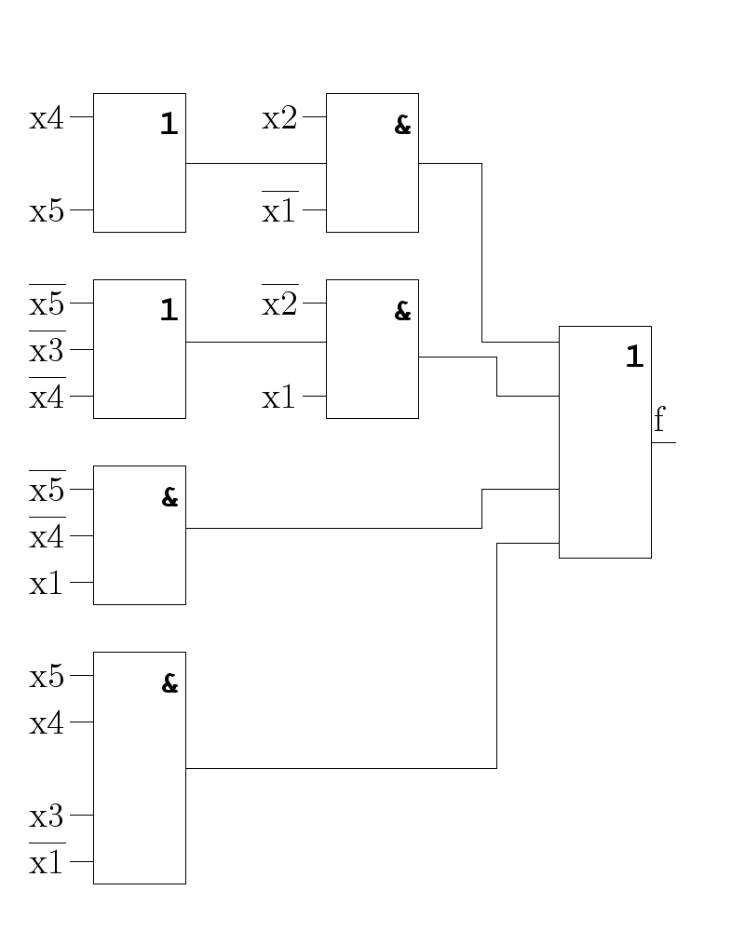

*T* = 3*t SQ* = 22

# 10

( - )

*f* = ((*X*5*|X*4*|X*1)*|*(*X*5*|X*4*|X*3*|X*1)*|*((*X*4*|X*5)*|X*2*|X*1)*|*((*X*5*|X*3*|X*4)*|X*2*|X*1))

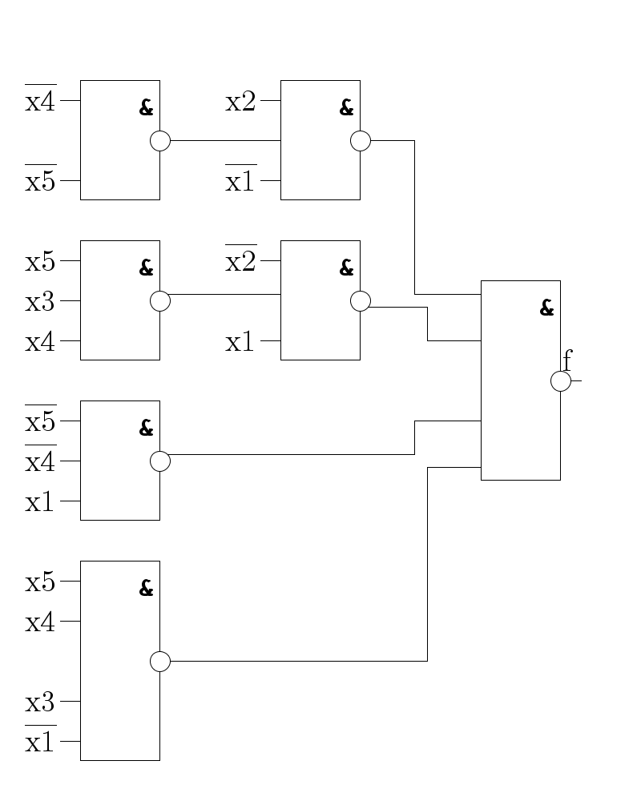

*T* = 3*t SQ* = 22

10

# 11 ( - )

*T* = 10*t SQ* = 46

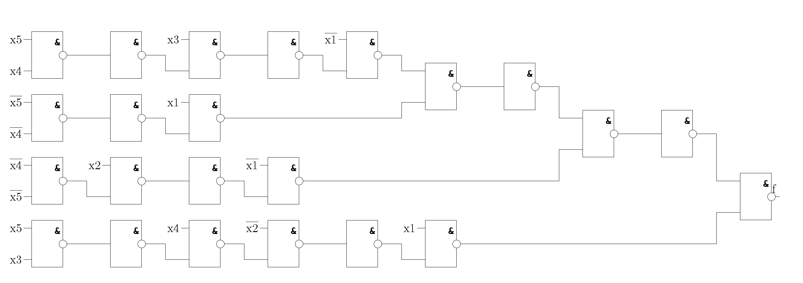

*f* = (((((*X*5*|X*4)*|X*1)*|*(((*X*5*|X*4)*|X*3)*|X*1))*|*(((*X*4*|X*5)*|X*2)*|X*1))*|*((((*X*5*|X*3)*|X*4)*|X*2)*|X*1))